AFDICA Charitable Services at Work Army Scholarship Foundation
A key component of AFDICA’s mission is advancing financial literacy. In 2023 AFDICA partnered with the Army Scholarship Foundation to provide scholarships to children or spouses of military members to pursue financial degrees. The four 2023 awardees for the 2023-2024 academic year are:
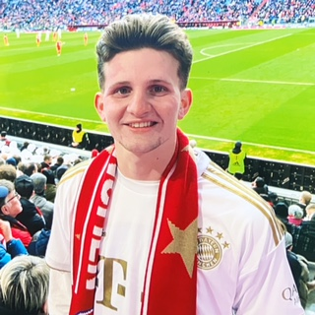
Brandon Carter of Duncan SC. Brandon is a junior at Clemson University in Clemson, SC. He graduated from James Byrnes High School in Duncan, SC. Brandon is majoring in business accounting. His father is retried Sergeant First Class Mark Carter who served in combat in Iraq and Afghanistan. He also served five extended deployments to Columbia in South America.

Ethan Hall of Rineyville, KY. Ehan is a sophomore at Cedarville University in Cedarville, Ohio, where he is majoring in business and business management. Ethan was homeschooled in high school by his parents. His father is retired Army sergeant Jeffrey Hall. Sergeant Hall served in combat in Iraq and Afghanistan, as well as overseas in Kuwait and Korea.

Jackson Tingler of Round Rock, TX. Jason is a junior at Mary Hardin-Baylor University in Belton, TX with a double major in Finance and Economics. His parents are former Specialist & Mrs. Thomas Tingler of Round Rock. Specialist Tingler served in combat in Operation Desert Storm and served with 2d Sqn, 5th Cavalry at Fort Hood.

Giselle Wipper of Golden. CO. Giselle graduated from D'Evelyn HS in Denver, CO and is entering the University of Colorado at Boulder in the fall where she will major in Finance and Business Management. Her mother is former Specialist Serena Wipper who served during Operation Desert Shield/Desert Storm.

