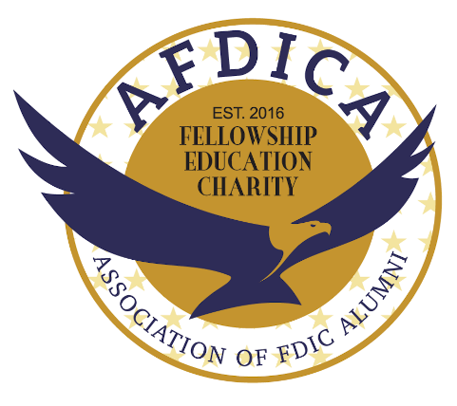
www.afdica.com

Who is the AFDICA?
The Association of Federal Deposit Insurance Alumni, Inc. (AFDICA) is a 501(c)(3) tax-exempt charitable organization. Membership in the AFDICA is limited to former employees of the Federal Deposit Insurance Corporation (FDIC) and the Resolution Trust Corporation. The AFDICA is not affiliated with the FDIC.
What does the AFDICA do?
The AFDICA was formed for the purposes of:
- Advancing financial literacy education to the public;
- Supporting local and national charitable causes; and
- Promoting social events for its members.
What Financial Literacy Curricula do AFDICA volunteers use?
AFDICA volunteer instructors use the Money Smart Curriculum developed by the FDIC and the Consumer Financial Protection Bureau such as:
- Money Smart for Adults;
- Money Smart for Young People;
- Money Smart for Older Adults;
- Money Smart for Small Business
The curriculum can be found at: www.fdic.gov/consumers/consumer/moneysmart
How to decide which Money Smart Curricula to use?
Often the nature and mission of the organization will suggest an appropriate program. All programs are able to be customized according to the learning goals. The AFDICA volunteer can work with the organization to tailor a program to meet your specific needs.

